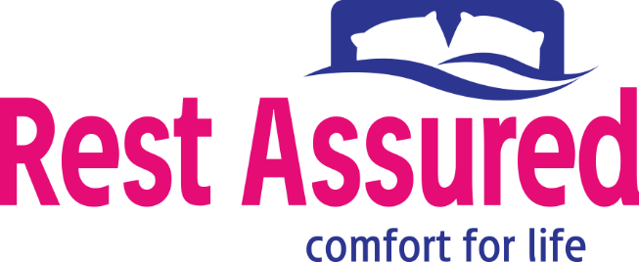
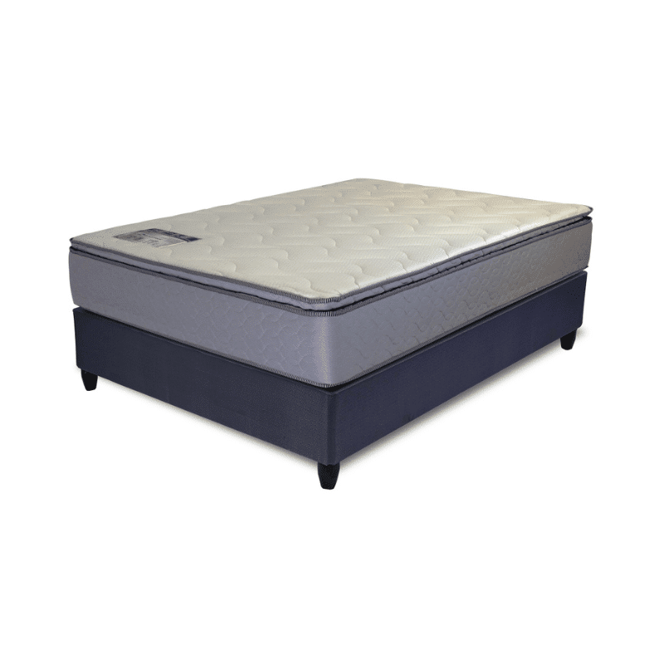

Model : Rest-A-Flex Base Set
Supplier/Manufacturer : Rest Assured
Range : Matrix
Prices – Bed Set :
- Single Bed Set – R5129
- Three Quarter Bed Set – R5779
- Double Bed Set – R6619
- Queen Bed Set – R7229
- King Bed Set – R9139
Prices – Mattress Only :
- Single Mattress Only – R3869
- Three Quarter Mattress Only – R4359
- Double Mattress Only – R5079
- Queen Mattress Only – R5599
- King Mattress Only – R6619
Prices - Extra Length Bed Set :
- Single Extra Length Bed Set – R5539
- Three Quarter Extra Length Bed Set – R6249
- Double Extra Length Bed Set – R7149
- Queen Extra Length Bed Set – R7809
- King Extra Length Bed Set – R9869
Prices - Extra Length Mattress Only :
- Single Extra Length Mattress Only – R4179
- Three Quarter Extra Length Mattress Only – R4709
- Double Extra Length Mattress Only – R5489
- Queen Extra Length Mattress Only – R6049
- King Extra Length Mattress Only – R7149

*Please use this link for guideline for creating the page* - https://www.bedsonline.co.za/product/rest-assured-rest-a-flex-medium-queen/
Rest Assured Link - https://restassured.co.za/our-ranges/matrix/rest-a-flex/

